**Team 45 Analysis/ Modeling Report**

**Locations with Highest Asthma Rates**

The five neighborhoods with the highest asthma rates are Hunts Point - Mott Haven, East Harlem, Crotona - Tremont, High Bridge - Morrisania, and Central Park - Morningside Heights.

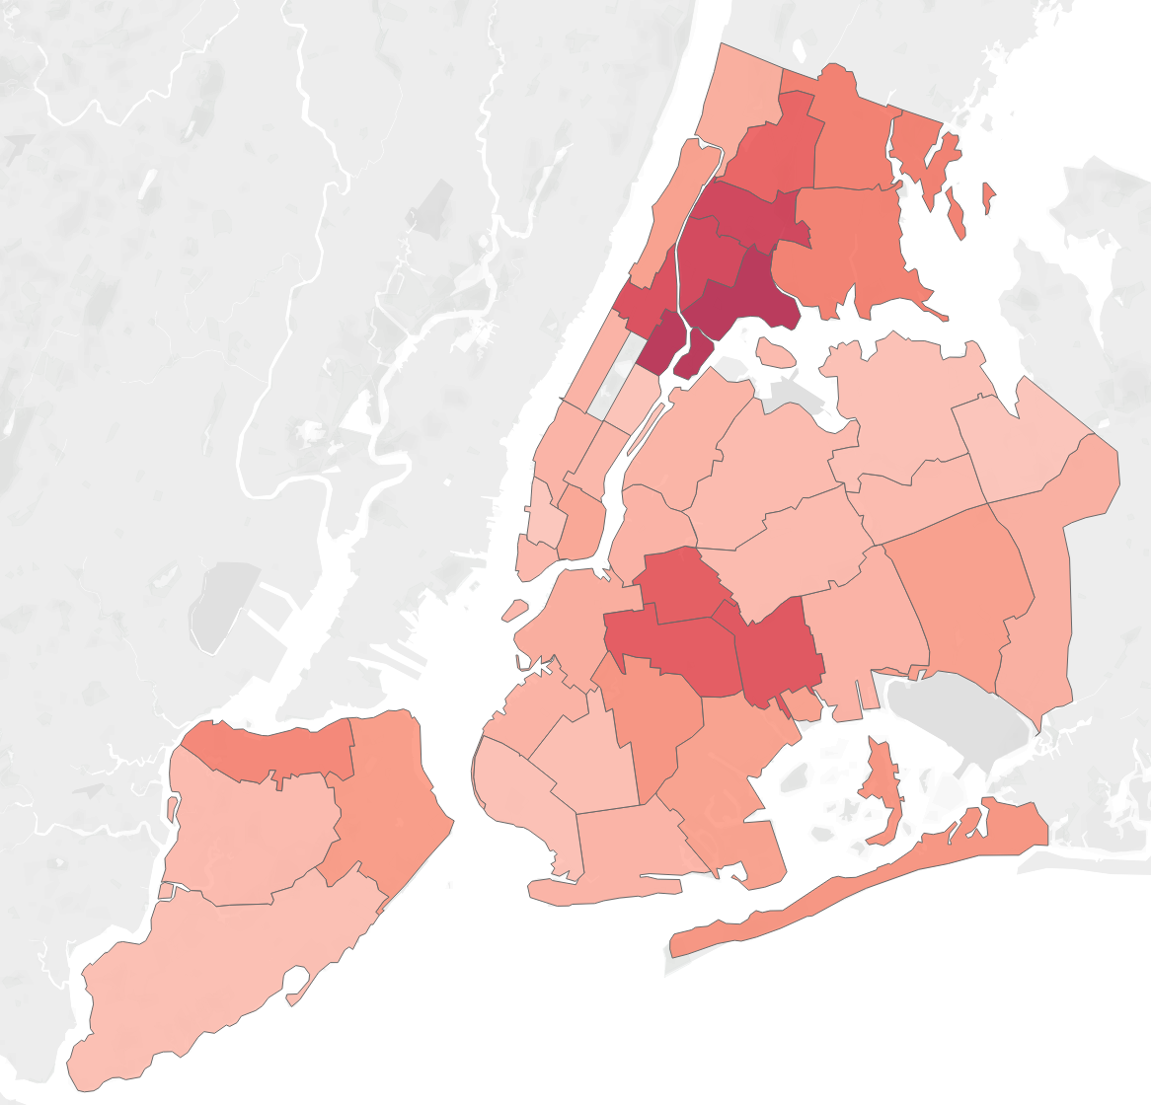

**Pollutant Levels in Neighborhoods with High Asthma Rates**

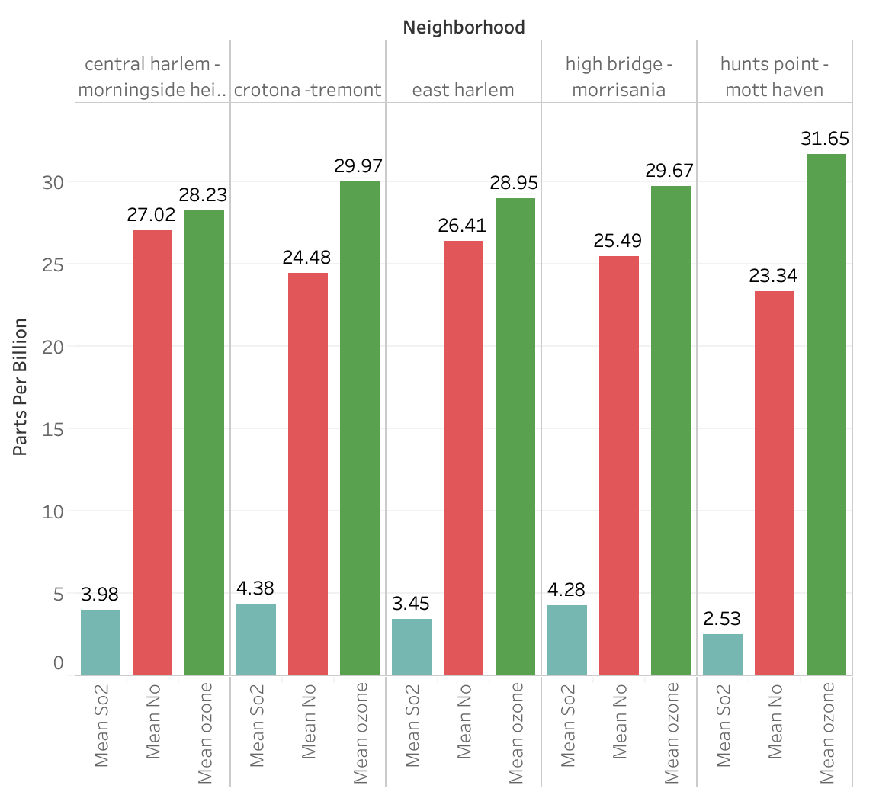

**How do these levels compare with the average yearly pollutant rates for all neighborhoods?**

The table shows the average of the mean yearly pollutant levels for all neighborhoods. Measurements are in parts per billion.

| Mean Sulfur | 2.51 |
| --- | --- |
| Mean Nitrogen Dioxide | 23.08 |
| Mean Ozone | 30.26 |

Each of the five neighborhoods has higher-than-average levels of Sulfur and Nitrogen Dioxide. Four of the neighborhoods have a lower than average level of ozone.

**A look at Fine Particulate Matter Levels in the Five Neighborhoods**

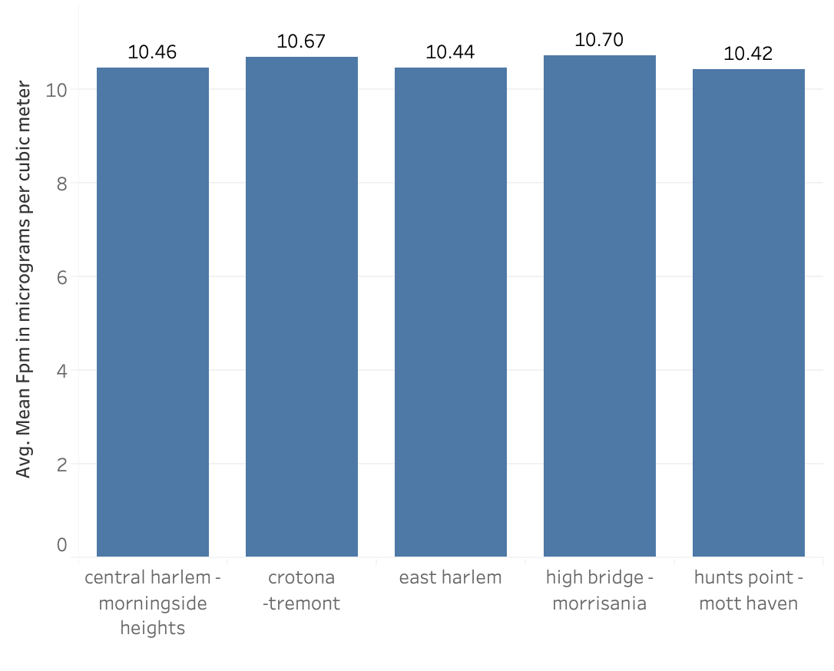

The average of the mean yearly fine particulate matter for all neighborhoods is 9.97 micrograms per cubic meter. The five neighborhoods included here all have a greater average of mean yearly fine particulate matter levels.

**How do the pollution levels in areas with high asthma rates compare to the areas with the highest pollution?**

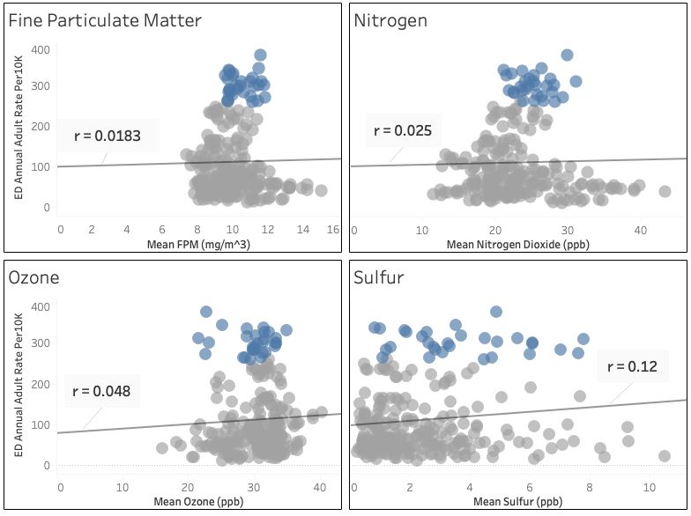

In the scatter plots above, the blue points represent the five locations with the highest asthma rates in New York City: Hunts Point - Mott Haven, East Harlem, Crotona - Tremont, High Bridge - Morrisania, and Central Park - Morningside Heights. We can see that there is a very correlation between each of the pollutants, and emergency department visits. In the scatter plot for the pollutant Nitogen Dioxide, the locations with the highest pollutant levels have the lowest asthma rates. The scatter plot for Sulfur shows a wide spread of pollution levels for areas with high and low asthma rates. The scatter plot for fine particulate matter shows a cluster of points mostly between 8 and 12 micrograms per cubic meter, corresponding to a wide range of asthma rates. The scatter plot for Ozone shows a similar trend with the majority of points between 25 and 35 parts per billion corresponding to a wide range of asthma rates. It is clear from these scatter plots that there are other factors besides air pollution that contribute to high emergency department visits for asthma.

**Social Determinants of Health (SDOH) in Neighborhoods with High Asthma Rates**

Social determinants of health are any non-medical factors that may influence differences in population health outcomes. Factors we analyzed amongst New York City’s population cover the economic stability, physical environment, health care system, and social context categories of SDOH.

**Poverty Levels - Economic Stability**

The graph shows the mean number of households in New York City that fall into each category of the Federal Poverty Level (FPL) in the USA.

* Below 100% FPL = Below $25,750
* 100 to 199% FPL = $25,750 to $51,499
* Below 200% FPL = Below $51,500
* 200 to 399% FPL = $51,500 to $102,999
* 400% FPL and above = $100,300 and above

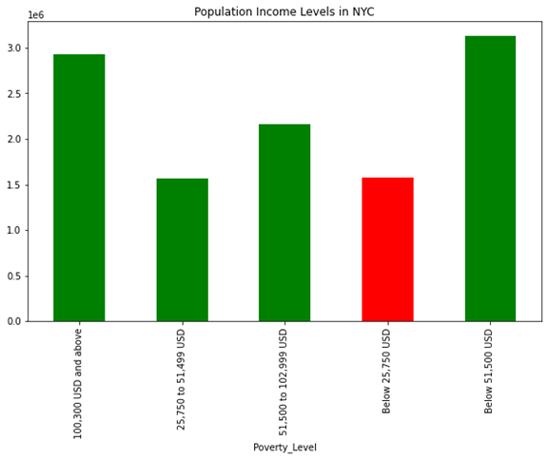

The data shows that the number of people that live with an income 400% FPL and above ($100,300 USD annual income and above) is the predominant group in NYC. The number of people that live 400% or more above the FPL are nearly twice the number of people living in poverty (income of below $25,750 USD annual income), giving some insight into the wealth distribution in NYC. It should be noted that the livable income for one adult (not including households with any dependable members) in NYC is $43,540 USD annual income (<https://livingwage.mit.edu/counties/36061>).

**Poverty Levels in Neighborhoods with High Asthma Rates**

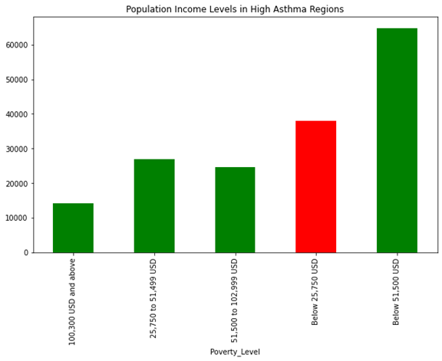

The wealth distribution in the neighborhoods with the highest asthma rates do not have a similar trend to the city as a whole. People living below the FPL make up the predominant group in the regions of NYC with the highest asthma rates. Taking a further look below, two of top asthma regions (University Heights and Highbridge) are the top two regions in NYC with the highest number of people that have income below the FPL.

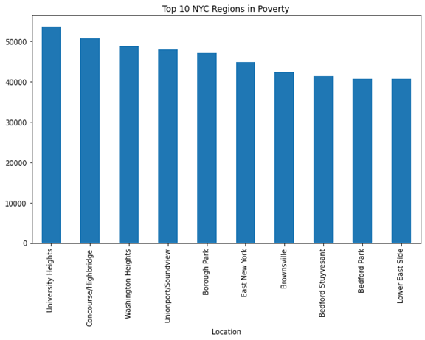

**Health Insurance - Health Care System**

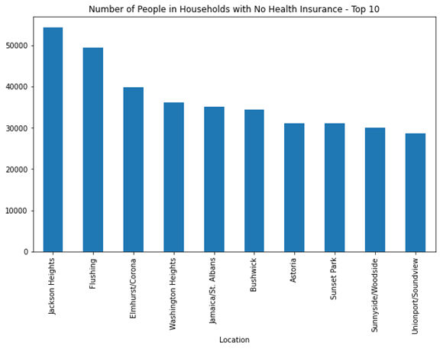

The figure above shows the top 10 neighborhoods in NYC with the highest rates of households with no health care insurance. None of the regions with the highest asthma rates in NYC are within the top 10 uninsured regions in NYC. Originally, we had hypothesized that there may be a correlation between being uninsured for healthcare and rates of emergency department visits. We expected that areas with the highest rates of asthma, as measured by ED visits for asthma, would have the highest insured populations. This was based on the assumption that being uninsured would act as a barrier to accessing health care for those that have asthma. Seeing as how none of the top asthma regions fall in the top uninsured (aka lowest insured) regions, there may be some truth to the hypothesis that healthcare insurance is a determinant of asthma exacerbation in NYC.

**Race/Ethnicity - Social Context**

|  |  |
| --- | --- |
|  |  |

The population distributions in the first row of graphs demonstrate the mean number of NYC residents from the year 2007 to 2014 by ethnic group and by ethinic group in poverty, respectively. The predominant race/ethnic group in poverty in NYC appears to be the Latino population followed by Black population.

The population distribution of people in poverty by race/ethnicity in the top asthma regions do not follow the general trend of NYC as a whole. In regions with high asthma the White population is a minority. Latinos are the predominant group living in poverty followed by the Black population. These findings do not coincide with findings in the literature that shows Black and American Indian/Alaska Native populations having the highest asthma rates in the USA. However, rates vary significantly among subgroups of latinos, with the highest asthma occurrence in any ethnic-subgroup being in 14% of Puerto Ricans across the USA from years 2016-2018 (<https://www.lung.org/research/trends-in-lung-disease/asthma-trends-brief/current-demographics>).

| Race/Ethnicity Graphs in NYC (Occurence of Poverty) | |
| --- | --- |
| Pop. by Ethnicity | Pop. by Ethnicity in Poverty |
| Other 2.200543e+05  Asian 1.095875e+06  Black 1.878944e+06  Latino 2.389002e+06  White 2.747519e+06 | Asian 199639.375001  White 325659.625003  Black 404223.500001  Latino 658471.250003 |
| % of Pop. in Poverty by Ethnicity   * Asian: 199639.375001 / 1.095875e+06 = 18.22% * White: 325659.625003 / 2.747519e+06 = 11.85% * Black: 404223.500001 / 1.878944e+06 = 21.51% * Latino: 658471.250003 / 2.389002e+06 = 27.56% | |

| Race/Ethnicity Graphs in Top Asthma Regions (Occurence of Poverty w Possible Correlation to Asthma) | |
| --- | --- |
| Pop. by Ethnicity | Pop. by Ethnicity in Poverty |
| Other 1777.079545  Asian 2440.647727  White 5811.852273  Black 36309.102273  Latino 59606.102273 | Asian 731.403509  White 1047.828125  Black 12000.640625  Latino 23995.578125 |
| % of Pop. in Poverty by Ethnicity   * Asian: 731.403509 / 2440.647727 = 29.97% * White: 1047.828125 / 5811.852273 = 18.03% * Black: 12000.640625 / 36309.102273 = 33.05% * Latino: 23995.578125 / 59606.102273 = 40.26% | |

| Intra-Race Poverty by Region | | |
| --- | --- | --- |
| **Race** | **All of NYC** | **Top Asthma Regions** |
| Asian | 18.22% | 29.97% |
| White | 11.85% | 18.03% |
| Black | 21.51% | 33.05% |
| Latino | 27.56% | 40.26% |

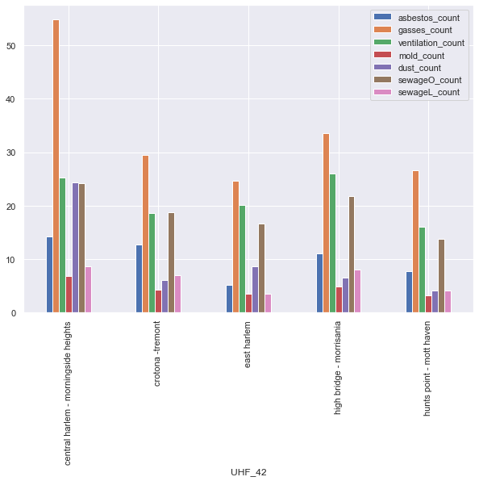

The above five neighborhoods are those with the top asthma rate. From the graph we can see that all of the neighborhoods all have highly elevated: gas, ventilation, and sewage, counts. Notably there’s a consistent ratio between the aforementioned variables. The graph will be updated to be normalized for the population. On broader analysis the individual complaint amount per neighborhood wasn’t outstanding. However, after normalizing for population we may find a distinct ratio for the top five neighborhoods.

**Top 5 Neighborhoods Ranked by Emergency Department Visits due to Asthma**

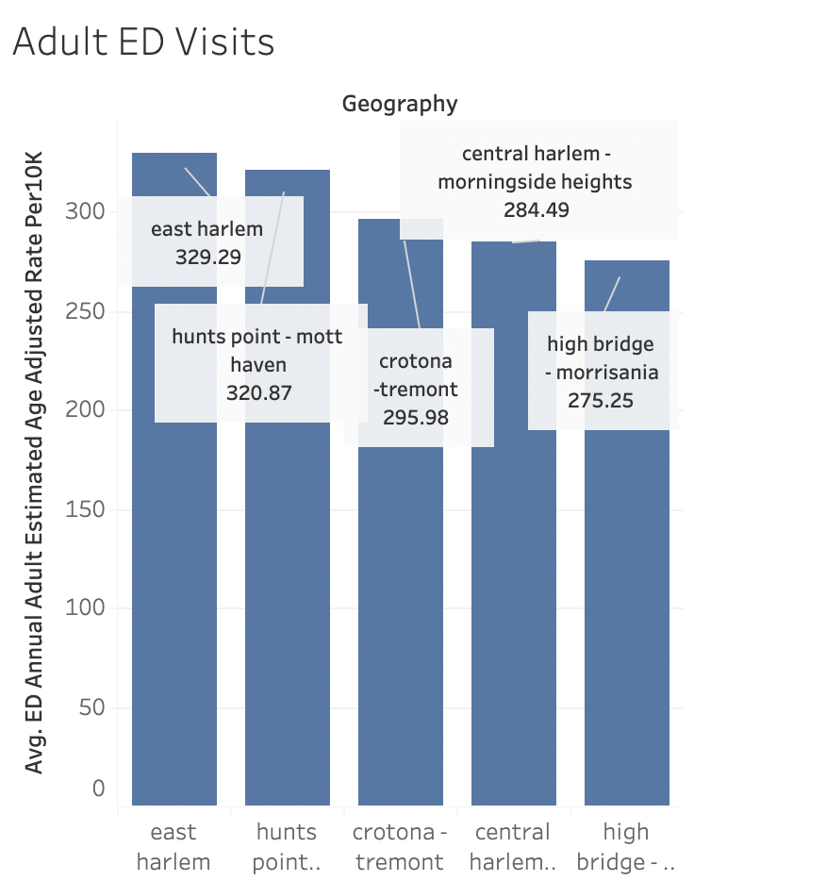

**Top 5 Neighborhoods Ranked by Hospitalizations due to Asthma**

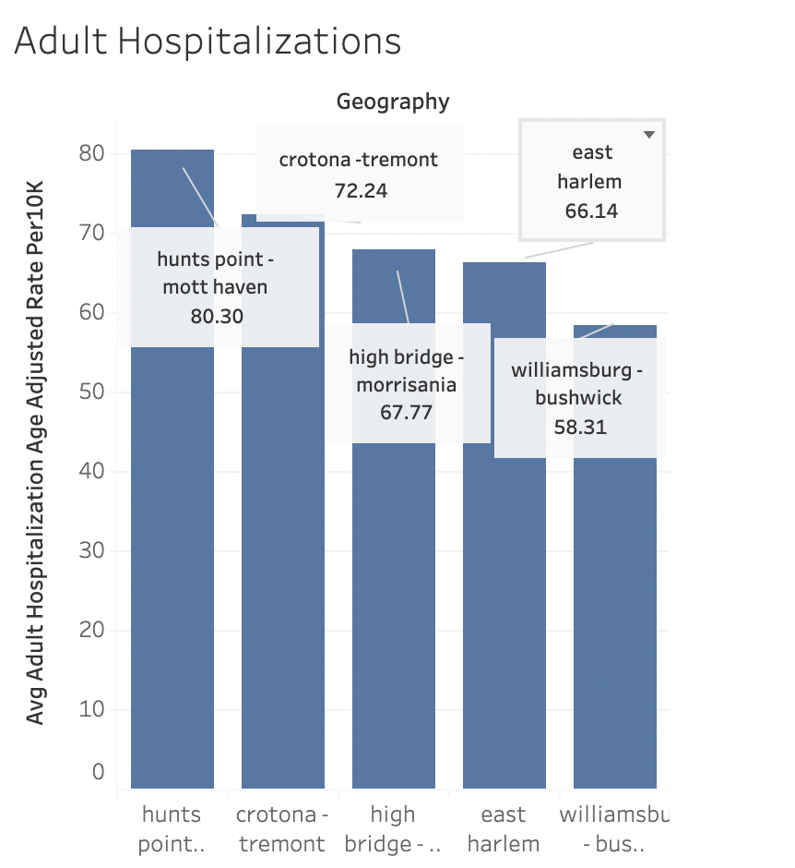

**Regression Analysis:**

**Link to python notebook on github:** [**https://tinyurl.com/zsza5v7d**](https://tinyurl.com/zsza5v7d)